St Mary's Parish Church, Greyhound Hill, Hendon NW4 4,1IT
Sacred Music for Passiontide
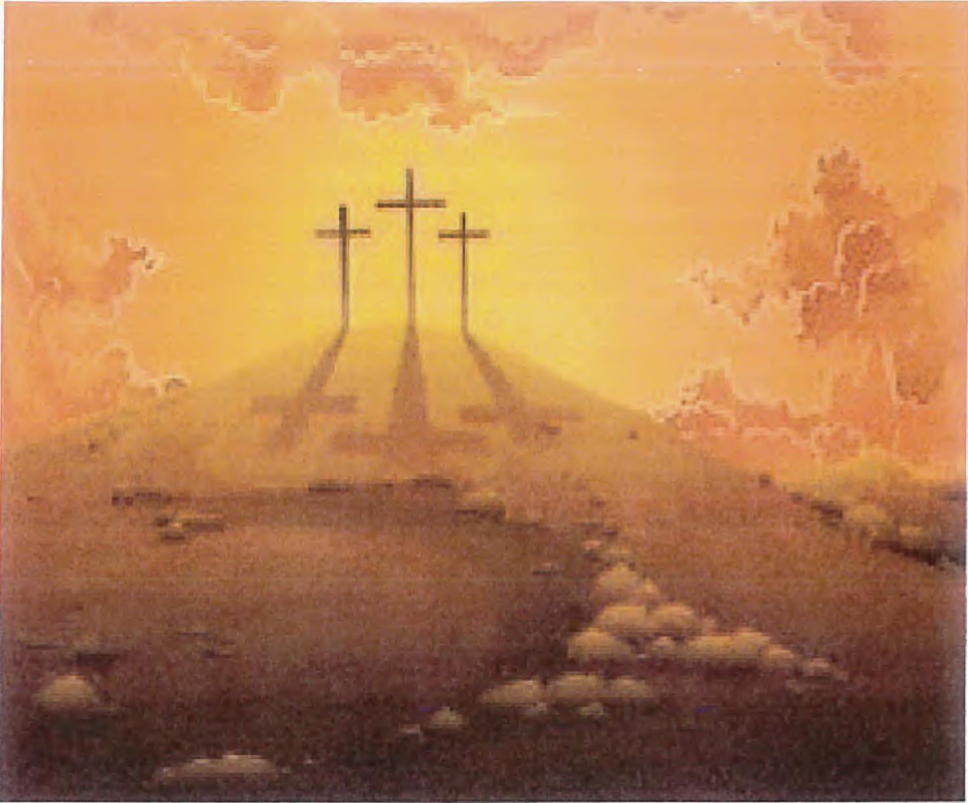
Two beautiful Baroque choral masterpieces
Sung by the Choir of Hendon St Mary
Directed by Richard Morrison
Johann Sebastian Bach: Jesu, meine Freude
Dieterich Buxtehude: Membra Jesu Nostri
Sunday 31st March 2019, at opm
Tickets: £8 (£5 concessions) from 020 8959 0207, or on the door

